DIRECTORATE OF INDUSTRIES
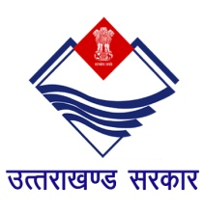
INDUSTRIAL AREA, PATEL NAGAR
DEHRADUN-248001
Tel no. 0135-2728227, Fax no. 0135-2728226
E-Mail: mpr@doiuk.org, Website: www.doiuk.org

“E Tender”

Proposals are invited from reputed/experienced firms for Selection of Travel Agency for Managing Travel Services during Uttarakhand Investors Summit-2018 scheduled to be held on 7th & 8th October 2018 at Dehradun. Details can be obtained from website www.doiuk.org & uktenders.gov.in
- Availability of Tender Document - Dated: 5.09.2018
- Last Date for submission of Tender- Dated: 18.09.2018 Upto 03.00 PM
Director, Industries Uttarakhand reserves the right to accept or reject any proposal or all the offers without assigning any reason.

Director, Industries

